Advanced Ceramics- #5 Throwing a set of 6 mugs or Rachel Dein Studio
Throwing a set of 6 mugs:
Work on a beautiful exact match of 6 look alike mugs. Don’t forget a handle. You can add decorative elements to these mugs if you wish.
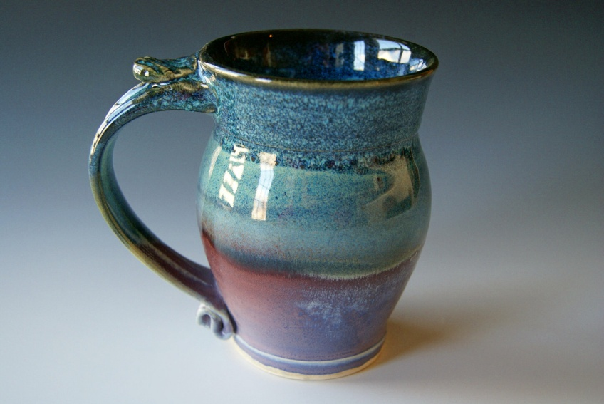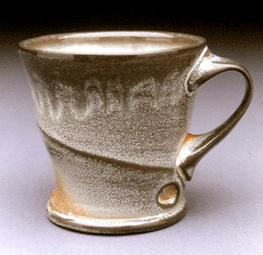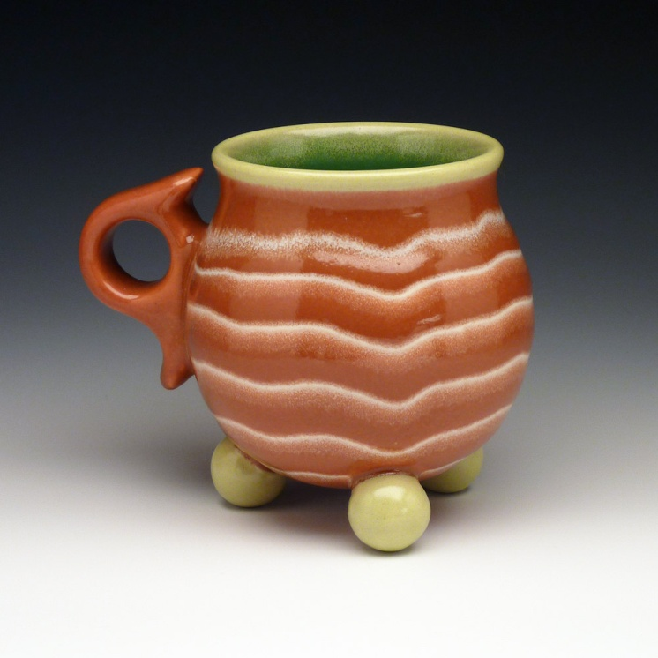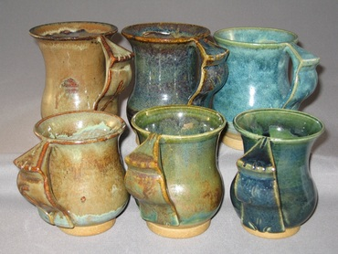

Rachel Dein , Tactile Studio
You are going to create a molded plate (or a series of) using items from nature to create the relief. You will need to bring in objects of interest such as leaves, flowers, twigs, grasses…
Rachel Dein's method of plaster casting captures flowers and foliage in a unique and delicate way. She creates her original casts by making an impression in wet clay and then pouring plaster directly over it. The clay captures the most intricate details, subtly accenting the plaster as it sets. Each clay mould can only be used once, making every piece unique. Casts are then finished and refined by hand; some finished tiles are also hand painted.
