Advanced Sculpture- #5 Cardboard Portrait or Hunter’s Trophy Plaque
Cardboard Portrait
You are going to create a self-portrait or a portrait of someone you know completely out of cardboard. The portrait must have some sort of dimension to it.
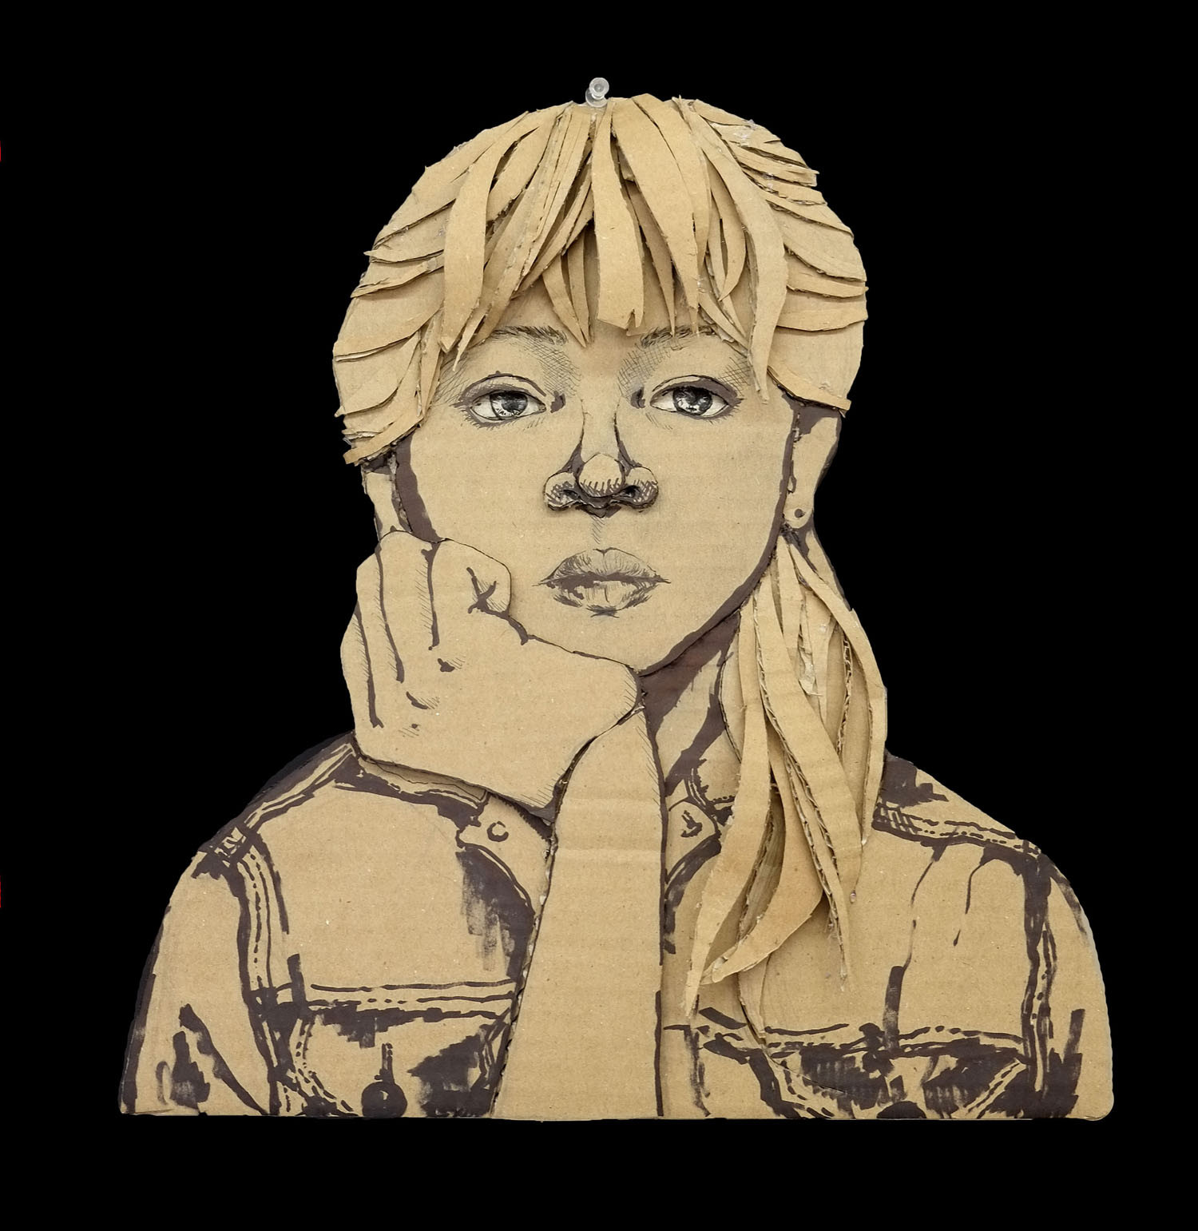
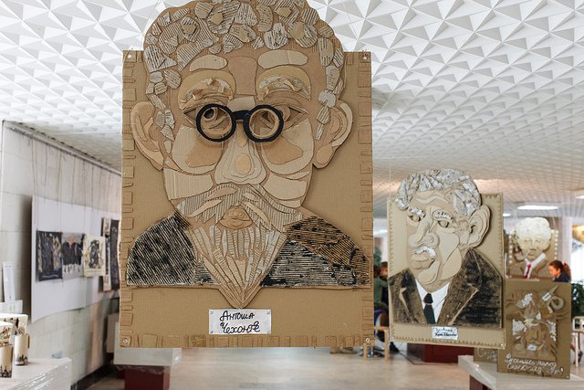
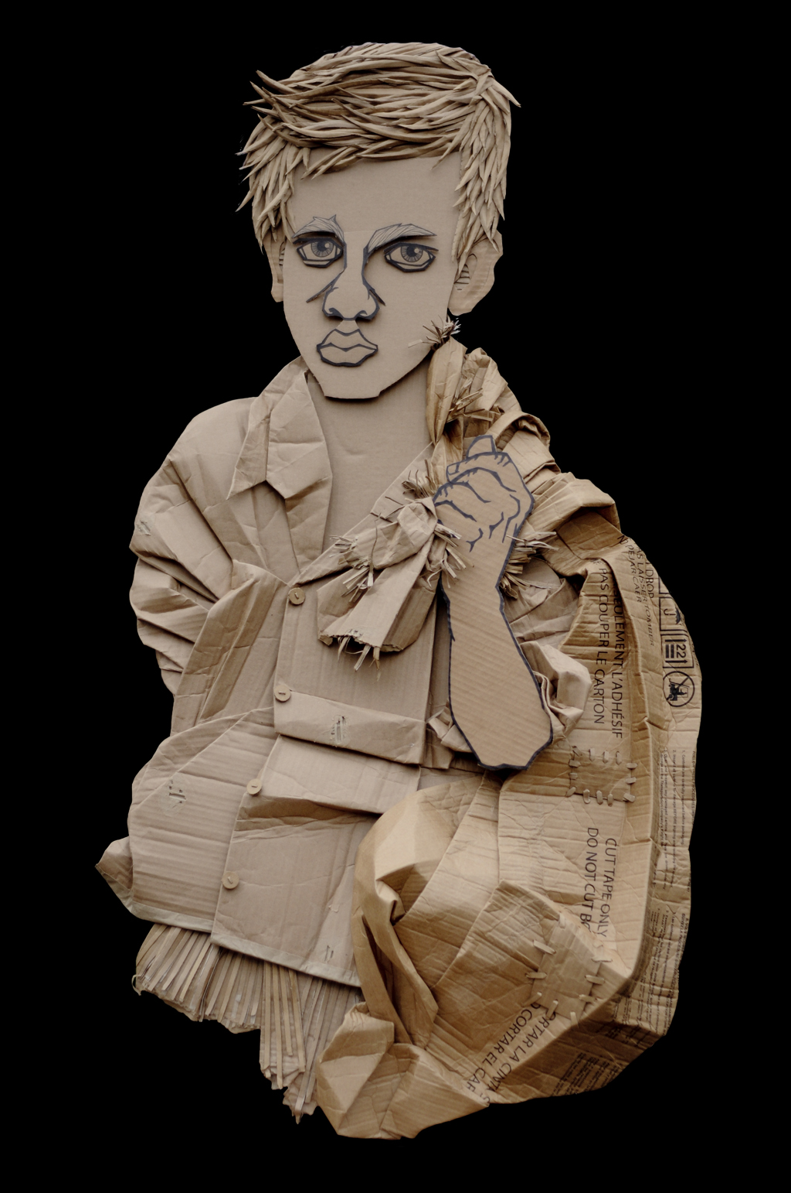
Hunter’s Trophy Plaque
This is much like the portrait you will be creating an animal head that is in the style of a Hunter’s Trophy. This should be completely 3-dimensional. Don’t forget the actual plaque for the animal head.

