Advanced Ceramics- #4 Coil w/a twist, Tromp L’Oeil, or Ceramic Tile Of Famous Piece of Art
COIL WITH A TWIST-
Think of an overall theme for your coil vessel. You are going to create a coil vessel but rather than coil the entire pot you will add slab elements to the pot. The slab element can be anything and can come off the off work in a 3-D fashion.
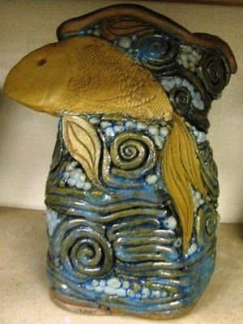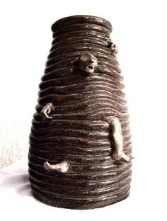
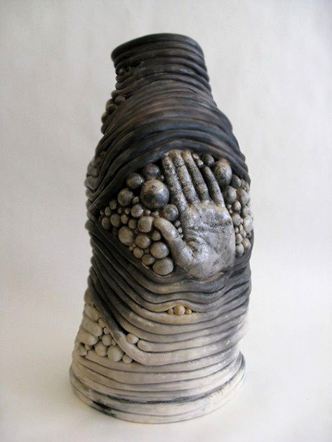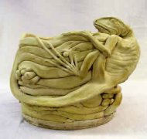

TROMP L’OEIL
The object is to create a work of art that looks real. Tromp l’oeil is to “fool the eye.” Try and create a vase or bowl or object that looks realistic.
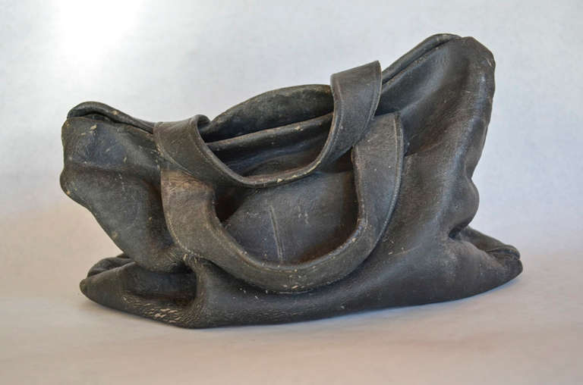
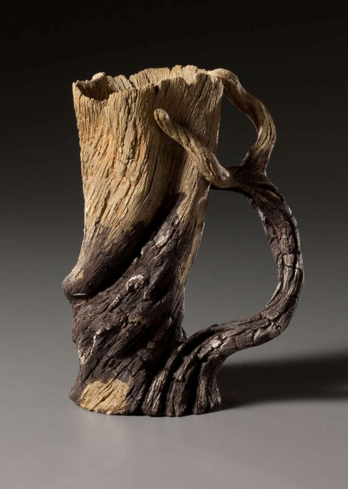

Ceramic Tile Relief of a famous piece of art:
Research a famous piece of artwork. You will be using a large, thick slab to carve into to re-create the painting. This should be flat on the bottom but 3 dimensional on the top.

