Advanced Ceramics- #2 Kimmy Cantrell Mask or Portrait
Start by looking at the artwork of Kimmy Cantrell. If you choose to create a Kimmy Cantrell mask, draw out your plan. Create a Mask using elements that Kimmy uses in his work.

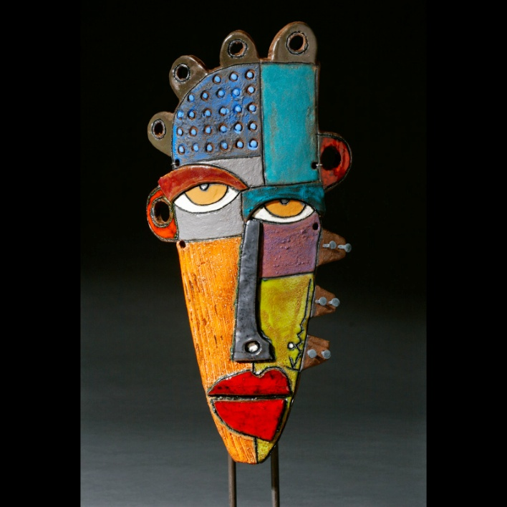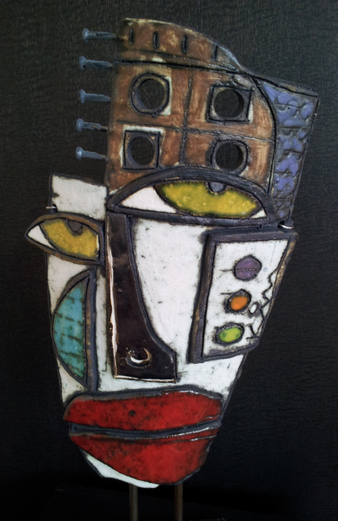
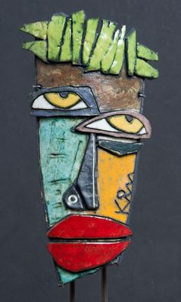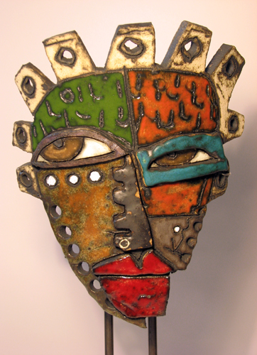

Portrait in Clay:
This can be a front view or side view of yourself or someone that you know. Cut the silhouette out of clay and be sure that the clay is thick enough to carve into, as well as add to. Create a realistic portrait using clay.
