Advanced Ceramics- #1 Simplified Animal Vessel or Coil with a twist
Simplified animal slab pot: Pick an animal that you can simplify. Create a vase or open pot using the simplified animal as inspiration. Add texture to the animal.
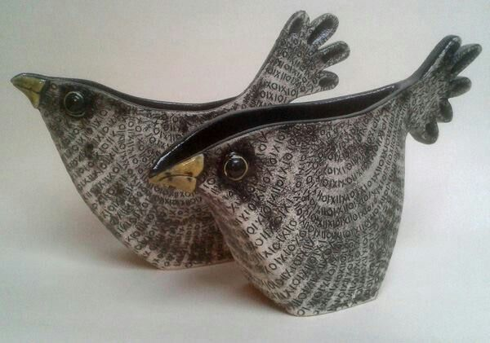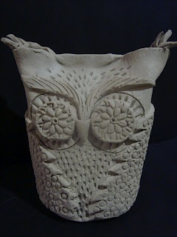

COIL WITH A TWIST-
Think of an overall theme for your coil vessel. You are going to create a coil vessel but rather than coil the entire pot you will add slab elements to the pot. The slab element can be anything and can come off the off work in a 3-D fashion.
