Reflective Self-Portrait- Advanced Drawing

Choose between drawing yourself from an extreme angle or your face wrapped with string, clothing, or a unique item. Medium is your choice. Try and use a different medium than you used last project. Work on 14 x 20 or 18 x 24 paper.

EXAMPLES OF EXTREME ANGLE PORTRAITS:
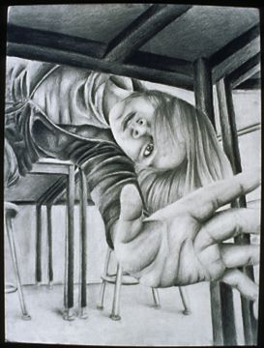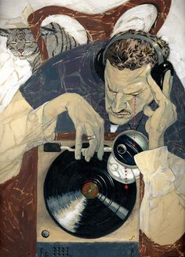
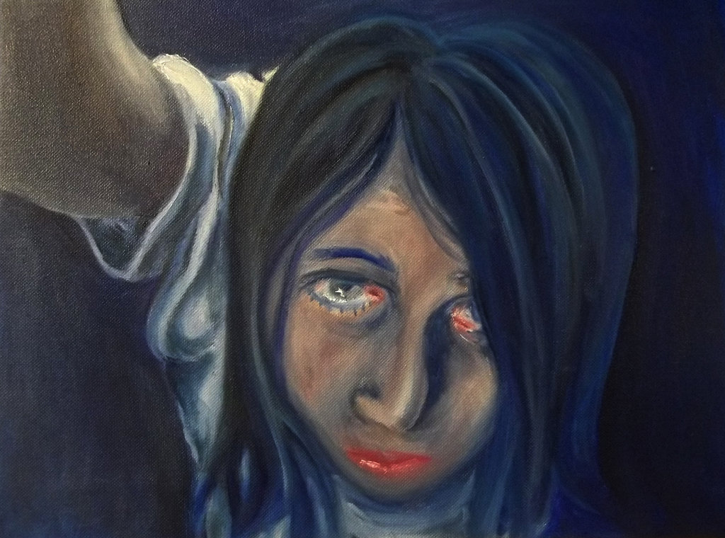
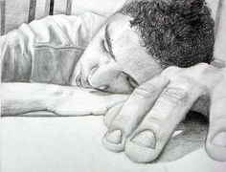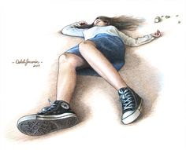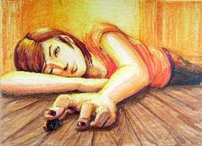

See below…
EXAMPLEs OF PORTRAITS WRAPPED WITH STRING, CLOTHING, OR A UNIQUE ITEM 