Advanced Drawing- Surreal Drawing Or Torn Paper Portraits
This is a complete creative, dream like drawing. Think about the work of Salvador Dali or Henri Magritte. They would come up with landscapes that seemed very dream like. Salvador Dali would leave a dream journal next to his bed and write down his dreams then paint his dreams. You will be coming up with a surreal scene of your own.

If you choose a torn paper portrait you will be using two separate pieces of paper to create on drawing. On the top layer you will be drawing a portrait in Ebony on the top sheet. On the second paper, using the same sized portrait as the top portrait, you will be drawing a “secret identity.” You will be tearing the top paper open to reveal part of the secret identity. See an example below.

SURREAL DRAWING EXAMPLES:
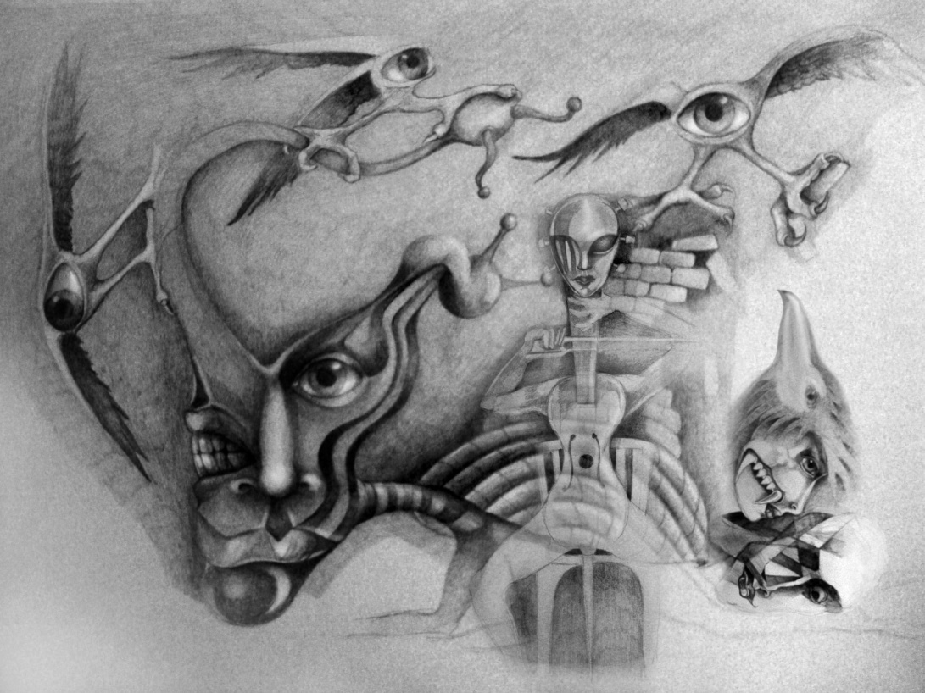
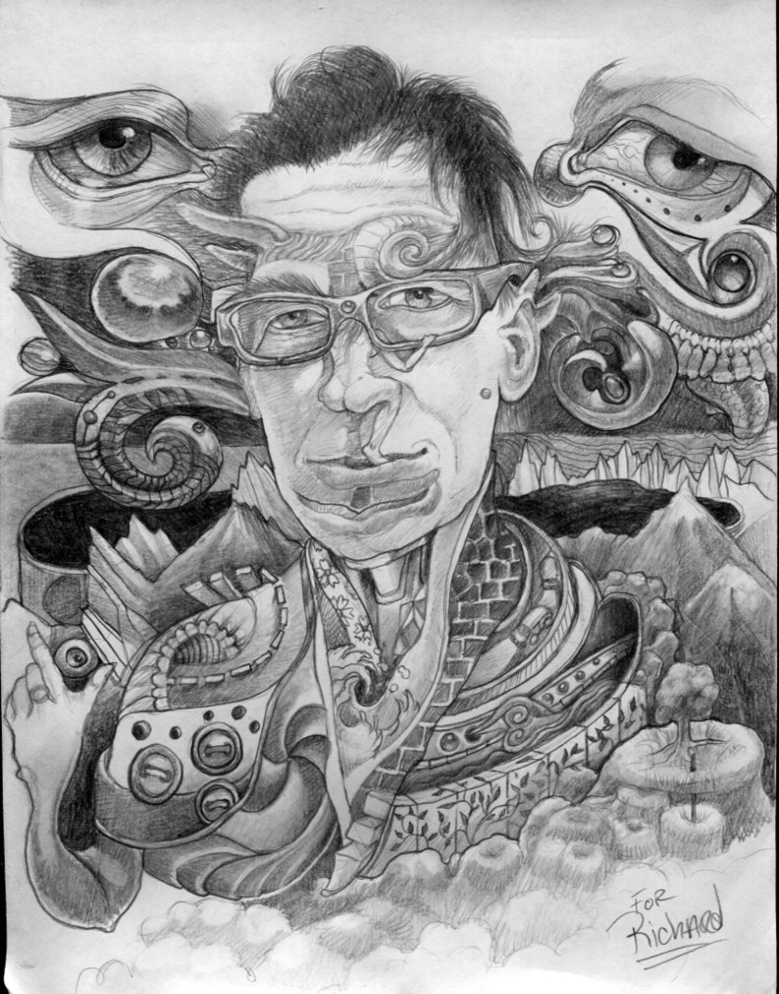
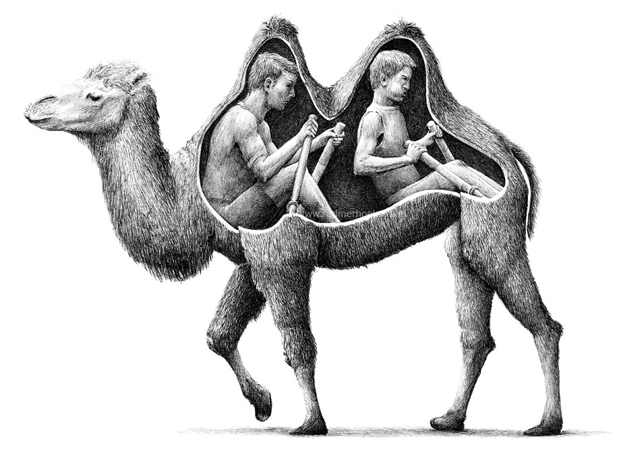
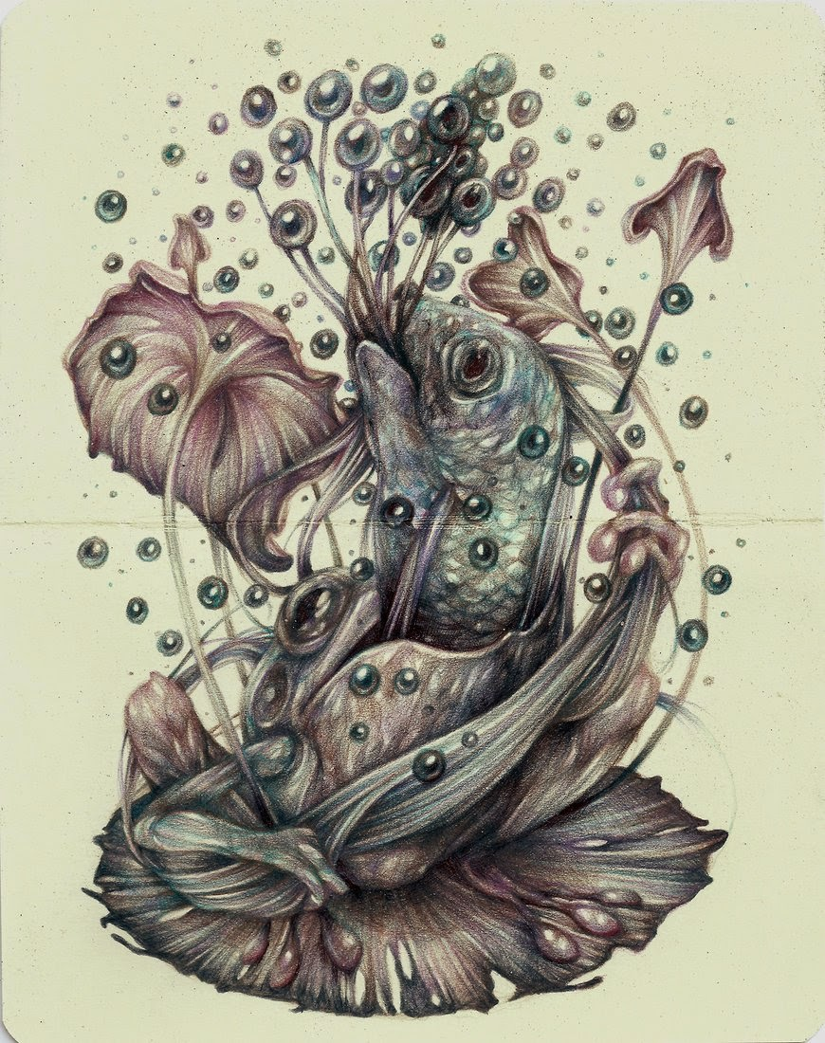
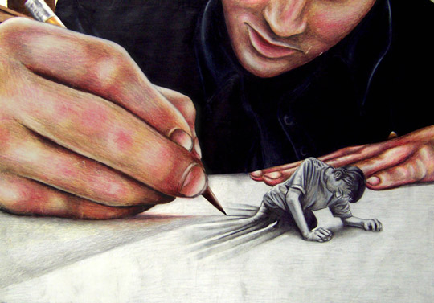

SECRET IDENTITY EXAMPLE
