Advanced Painting- #4 Architectural study in detail, Architectural abstract, or Surreal Painting
Architectural Detail: Find a detailed piece of architecture and draw a portion of it out using pencil. This should be drawn on watercolor paper. Draw lightly. You will then paint the drawing in using watercolor washes. Don’t forget to keep some sparkling whites! Mix colors so they are not so generic. When dry use a fine tip sharpie to outline the details of the building.
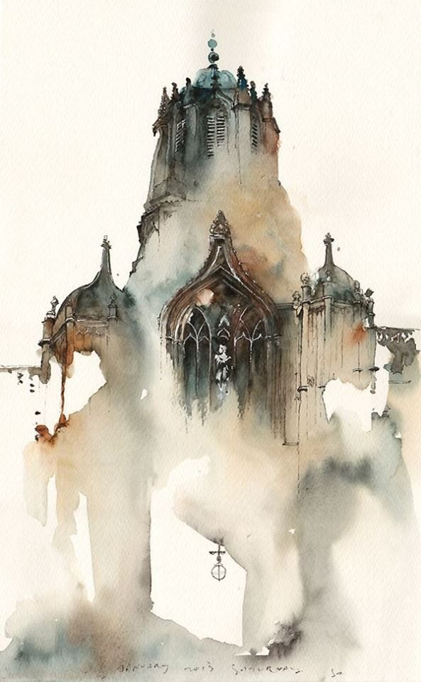

Architectural Abstract: Find a city scape that is interesting. You will need to lightly sketch out the buildings but don’t add details. Use a palette knife to smear oils to create an abstracted version of your cityscape.

Surreal Painting: This painting can be done in any wet medium. A surreal scene is a dreamlike scene that doesn’t necessarily make any sense. Use your imagination!
