Advanced Sculpture- #2 Bird Bottles, Embossed Metal Encaustics, or Giacometti inspired sculpture
Bottle Bird:
Bring in an empty wine bottle or tall glass bottle. Create a bird shape out of newspaper, tape, and paper mache’. Be sure to accentuate the body parts. Let dry, then draw on the designs of your bird. Paint.

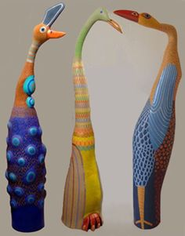

Embossed Metal Encaustics:
Encaustic painting is enjoying a resurgence because of modern techniques, tools and materials. While encaustic painting requires moving molten wax from a heating element to a surface, the technique used in this lesson plan creates textured “reservoirs” in metal foil that channel and cradle sprinkled wax chips as they melt. Interesting dimensions and contrasts between the metal and translucent wax occur when cooled.
See me for actual plan on how to construct this.
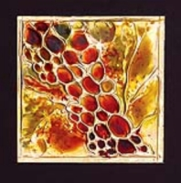
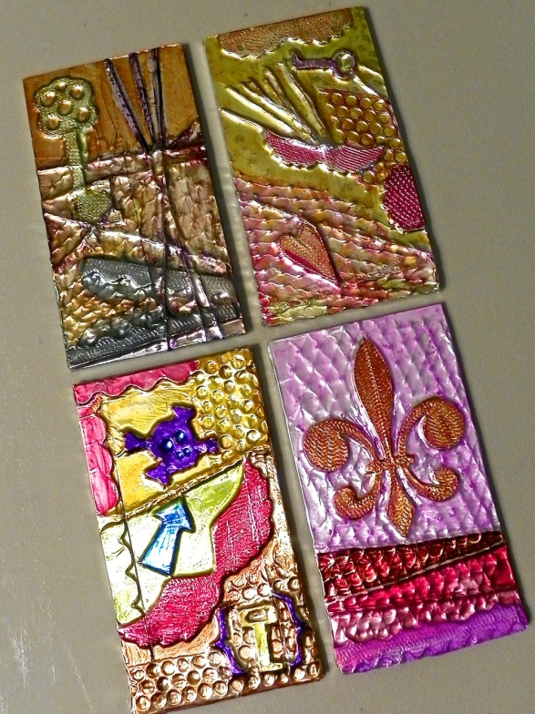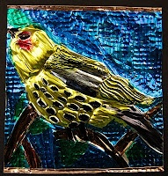
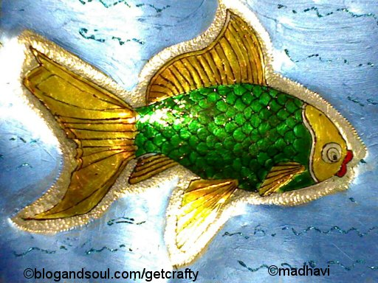

Giacometti inspired sculpture:
Alberto Giacometti was a famous sculptor and painter that is well known for his elongated sculptures of people. Create a sculpture out of wire, tape, and paper mache’ or paper pulp that is inspired by Giacometti.
