**Advanced Sculpture- #1 Paper relief or Wire in Motion**

Paper Relief Sculpture:

With this project you are to think of an overall scene. You will create this scene completely out of paper, on top of paper, on top of paper. This can be done in all white or you can use colored paper. You can choose to add color to the paper as well. You need to come up with a way to create the three dimensional look either by using tabs on back of your cut out elements or using 3-d o dots.

EXAMPLES:

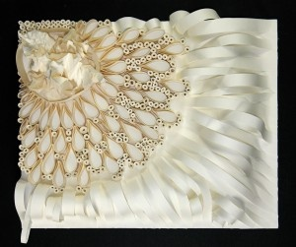 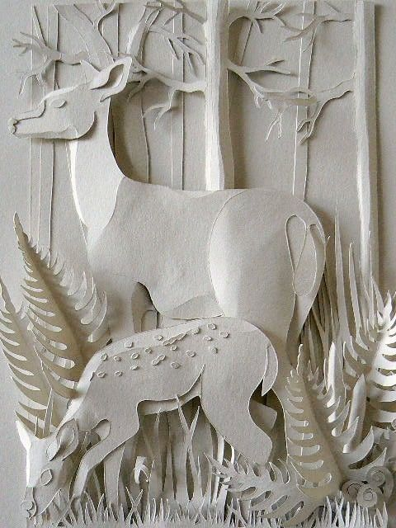

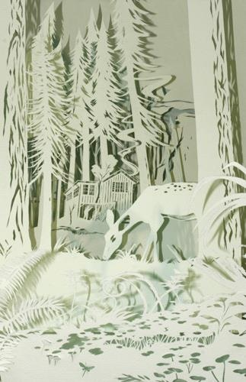 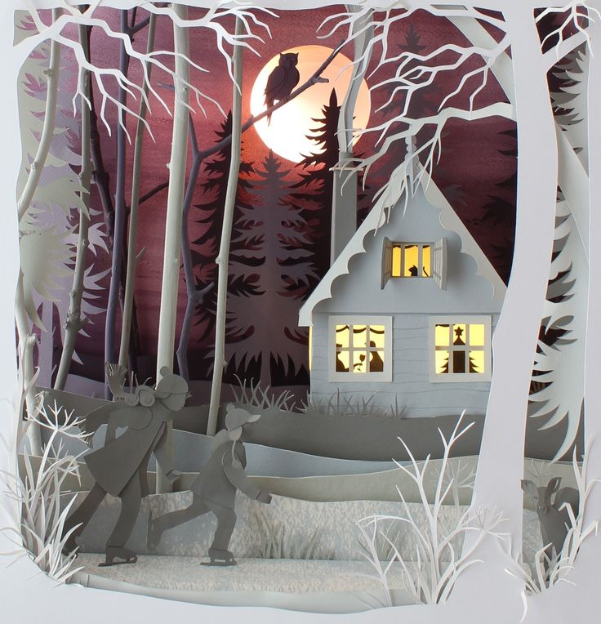

Wire in Motion:

Create a wire sculpture that is showing motion. You can add cut metal pieces to this project to add details that you would like.

